ECON300 Fundamentals of Economics
Homework 1
Note: 50 points in total.

NAME:___ ID: _____

I. Multiple Choices (1 pt each)
1. In economics, choices must be made because we live in a world of
A) unemployment.
B) scarcity.
C) greed.
D) unlimited resources.

2. Holding all other personal characteristics-such as age, gender, and income-constant, economists would expect that
A) people with health insurance will be less likely to be overweight than people without health insurance.
B) people with health insurance will be more likely to be overweight than people without health insurance.
C) people with health insurance will be equally likely to be overweight as people without health insurance.
D) there is no correlation between having health insurance and being overweight.

3. DeShawn's Detailing is a service that details cars at the customers' homes or places of work. DeShawn's cost for a basic detailing package is $40, and he charges $75 for this service. For a total price of $90, DeShawn will also detail the car's engine, a service that adds an additional $20 to the total cost of the package. Should DeShawn continue to offer the engine detailing service?
A) Yes, he still makes a profit by selling the engine detailing service with the basic detailing package.
B) Yes, but only if he raises the price of the basic detailing package.
C) No, his marginal benefit is less than his marginal cost.
D) More information is needed for DeShawn to make this decision.

4. The Coffee Nook, a small cafe near campus, sells cappuccinos for $2.50 and Russian tea cakes for $1.00 each. What is the opportunity cost of buying a cappuccino?
A) 2 1/2 Russian tea cakes
B) 2/5 of a Russian tea cake
C) $2.50
D) $1.00

5. Mr. Peabody chooses to invest in companies that produce goods and services based on consumer preferences. Mr. Peabody is investing in companies that are attempting to be
A) allocatively efficient.
B) productively efficient.
C) guaranteed to make a profit.
D) all of the above

6. Which of the following is a normative economic statement?
A) Rising global demand for coal has led to increases in the price of coal.
B) With rising mortgage rates and rising unemployment rates, the number of unsold homes has increased.
C) The state of Texas is considering increasing funds for light-rail development to promote the use of public transportation.
D) Pharmaceutical manufacturers should not be allowed to patent their products so prescription drugs would be more affordable.

7. Which of the following statements is true about profit?
A) Profit refers to the revenue received from the sale of a quantity of goods.
B) Profit is calculated by multiplying price and quantity sold.
C) The terms "accounting profit" and "economic profit" can be used interchangeably.
D) Profit is the difference between revenue and cost.

8. The attainable production points on a production possibility curve are
A) the horizontal and vertical intercepts.
B) the points along the production possibilities frontier.
C) the points outside the area enclosed by the production possibilities frontier.
D) the points along and inside the production possibility frontier.

9. Pierre can produce either a combination of 20 bow ties and 30 neckties or a combination of 35 bow ties and 15 neckties. If he now produces 35 bow ties and 15 neckties, what is the opportunity cost of producing an additional 15 neckties?
A) 2 bow ties
B) 15 bow ties
C) 20 bow ties
D) 35 bow ties

10. If the best surgeon in town is also the best at cleaning swimming pools, then according to economic reasoning, this person should
A) should pursue the activity he enjoys more.
B) specialize in cleaning swimming pools because it is more labor-intensive.
C) split his time evenly between being a surgeon and cleaning swimming pools.
D) specialize in being a surgeon because its opportunity cost is lower.

11) If the Apple iPhone and the Samsung Galaxy are considered substitutes, then, other things equal, an increase in the price of the iPhone will
A) decrease the demand for the iPhone.
B) increase the demand for the Galaxy.
C) increase the quantity demanded for the Galaxy.
D) increase the quantity demanded for the iPhone.

12) If, in response to an increase in the price of chocolate the quantity of chocolate demanded decreases, economists would describe this as
A) a decrease in demand.
B) a decrease in quantity demanded.
C) a change in consumer income.
D) a decrease in consumers' taste for chocolate.

13) A change in all of the following variables will change the market demand for a product except
A) the price of the product.
B) population and demographics.
C) income.
D) tastes.

14) If an increase in income leads to in an increase in the demand for peanut butter, then peanut butter is
A) a neutral good.
B) a normal good.
C) a necessity.
D) a complement.

15) Last year, the Pottery Palace supplied 8,000 ceramic pots at $40 each. This year, the company supplied the same quantity of ceramic pots at $55 each. Based on this evidence, The Pottery Palace has experienced
A) a decrease in supply.
B) an increase in supply.
C) an increase in the quantity supplied.
D) a decrease in the quantity supplied.

16) Which of the following would cause a decrease in the supply of milk?
A) an increase in the price of cookies (assuming that milk and cookies are complements)
B) a decrease in the price of milk
C) an increase the price of a product that producers sell instead of milk
D) an increase in the number of firms that produce milk

17) If a firm expects that the price of its product will be higher in the future than it is today
A) the firm will go out of business.
B) the firm has an incentive to increase supply now and decrease supply in the future.
C) the firm has an incentive to decrease quantity supplied now and increase quantity supplied in the future.
D) the firm has an incentive to decrease supply now and increase supply in the future.

18) Paul goes to Sportsmart to buy a new tennis racquet. He is willing to pay $200 for a new racquet, but buys one on sale for $125. Paul's consumer surplus from the purchase is
A) $325
B) $200
C) $125
D) $75

19) An increase in input costs in the production of electric automobiles caused the price of electric automobiles to rise. Holding everything else constant, how would this affect the market for gasoline-powered automobiles (a substitute for electric automobiles)?
A) The supply of gasoline-powered automobiles would increase and the equilibrium price of gasoline-powered automobiles would decrease.
B) The demand for gasoline-powered automobiles would increase and the equilibrium price of gasoline-powered automobiles would increase.
C) The demand for gasoline-powered automobiles would decrease because consumers could afford to buy fewer gasoline-powered automobiles.
D) The demand for gasoline-powered automobiles would increase and the equilibrium price of gasoline-powered automobiles would decrease.

20) Assume that both the demand curve and the supply curve for MP3 players shift to the right but the demand curve shifts more than the supply curve. As a result
A) both the equilibrium price and quantity of MP3 players will increase.
B) the equilibrium price of MP3 players will increase; the equilibrium quantity may increase or decrease.
C) the equilibrium price of MP3 players may increase or decrease; the equilibrium quantity will increase.
D) the equilibrium price of MP3 players will decrease; the equilibrium quantity may increase or decrease.

21) Assume that both the demand curve and the supply curve for MP3 players shift to the right but the supply curve shifts more than the demand curve. As a result
A) both the equilibrium price and quantity of MP3 players will decrease.
B) the equilibrium price of MP3 players will decrease; the equilibrium quantity will increase.
C) the equilibrium price of MP3 players may increase or decrease; the equilibrium quantity will decrease.
D) the equilibrium price of MP3 players will increase; the equilibrium quantity will decrease.

22) Let D = demand, S = supply, P = equilibrium price, Q = equilibrium quantity. What happens in the market for electric vehicles if the government offers incentives to manufacturers to produce more electric vehicles?
A) D increases, S no change, P and Q increase
B) S increases, D no change, P decreases, Q increases
C) D and S increase, P and Q decrease
D) D no change, S increases, P decreases, Q decreases

23) Which of the following would cause both the equilibrium price and equilibrium quantity of oysters (assume that oysters are a normal good) to decrease?
A) an increase in consumer income
B) an oil spill that sharply reduces oyster output
C) a decrease in consumer income
D) a technological advancement in the production of oysters

II. Essays (2 pts each)

Table 1-6
Hours  Open | Total Revenue (dollars) | Marginal Benefit | Marginal Cost
1 | $275 | 275 | 25
2 | 375 | 100 | 25
3 | 450 | 75 | 25
4 | 500 | 50 | 25
5 | 530 | 30 | 25
6 | 550 | 20 | 25

Ivan runs a custom jewelry shop in Sparkle City. He is debating whether he should extend his hours of operation. Ivan figures that his sales revenue will depend on the number of hours the jewelry shop is open as shown in the table above. He would have to hire a worker for those hours at a wage rate of $25 per hour.

1) Refer to Table 1-6. Using marginal analysis, determine how many hours should Ivan extend his hours of operations?
- He should extend his hours of operations to 5 hours.

Figure 2-8
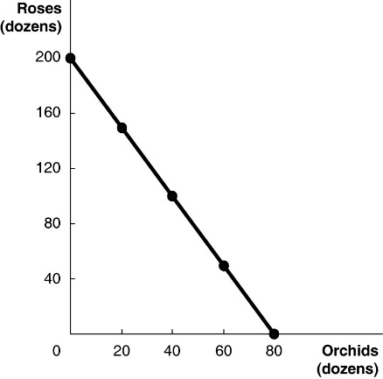

Figure 2-8 above shows the production possibilities frontier for Vidalia, a nation that produces two goods, roses and orchids.

2) Refer to Figure 2-8. What is the opportunity cost of 80 dozen orchids?
- Opportunity cost of 80 dozen orchids is 200 dozen roses
3) Refer to Figure 2-8. What is the opportunity cost of one dozen orchids?
- Opportunity cost of one dozen orchids is 200/80 = 2.5 dozen roses
4) Refer to Figure 2-8. If Vidalia chooses to produce 60 dozen orchids, how many roses can it produce to maximize production?
- It can produce 50 dozen roses to maximize production

5) Refer to Figure 2-8. If Vidalia chooses to produce 50 dozen roses, how many orchids can it produce to maximize production?
- It can produce 60 dozen orchids to maximize production

Table 2-21
 | Digital Camera | Wheat (bushels)
A | 100 hours | 5 hours
B | 90 hours | 3 hours

This table shows the number of labor hours required to produce a digital cameras and a bushel of wheat in country A and country B.

6. Which country has an absolute advantage in the production of digital cameras?
- Country B has an absolute advantage in the production of digital cameras
7. What is A's opportunity cost of producing one digital camera?
- A's opportunity cost of producing one digital camera is 100/5 = 20 bushels of wheat
8. What is B's opportunity cost of producing one digital camera?
- B's opportunity cost of producing one digital camera is 90/3 = 30 bushels of wheat

9. What is A's opportunity cost of producing one bushel of wheat?
- A's opportunity cost of producing one bushel of wheat is 5/100 = 0.05 digital camera

10. If each country specializes in the production of the product in which it has a comparative advantage, who should produce digital cameras?
- Country A should produce digital cameras

Figure 3-1
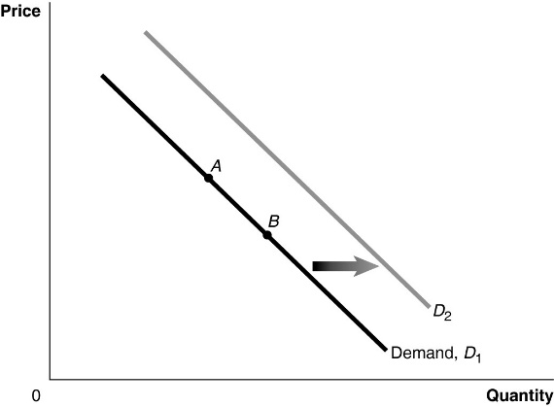

11) Refer to Figure 3-1. If the product represented is an inferior good, an increase in income would be represented by a movement from
A) A to B.
B) B to A.
C) D1 to D2.
D) D2 to D1.

12) Refer to Figure 3-1. A decrease in the price of the product would be represented by a movement from
A) A to B.
B) B to A.
C) D1 to D2.
D) D2 to D1.

Figure 3-4
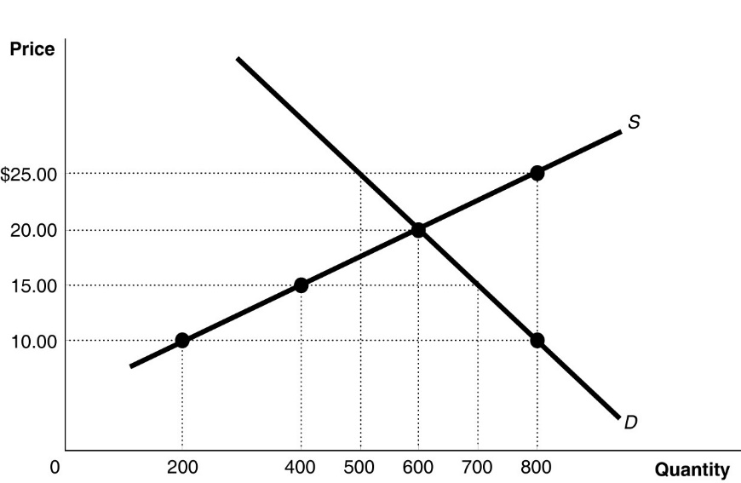

13) Refer to Figure 3-4. If the price is $10, is there a shortage or surplus? How much?
- If the price is $10, there is a shortage of 600 in quantity
14) Refer to Figure 3-4. If the current market price is $10, the market will achieve equilibrium by
A) a price increase, increasing the supply and decreasing the demand.
B) a price decrease, decreasing the supply and increasing the demand.
C) a price decrease, decreasing the quantity supplied and increasing the quantity demanded.
D) a price increase, increasing the quantity supplied and decreasing the quantity demanded.

